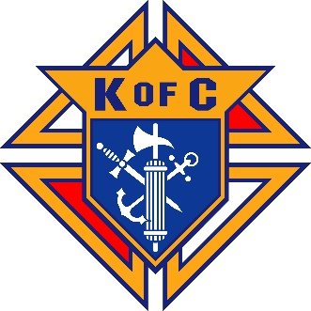
2025 Ascension Knights of Columbus Charity Golf Tournament
Falcon Ridge Golf Club
20200 Prairie Star Parkway, Lenexa, KS 66220. 913-393-4653
∙ Date: Monday, Sept 29, 2025
∙ Registration 12:00 PM ∙ Tee Off: 01:00 PM Shotgun Start
∙ Format: Foursome Scramble
∙ Entry Fee: $200 per player; $800.00 per team
Includes On-Course Beverages, Hole Competitions, Dinner, Awards & Prizes Presentation
*** MULLIGANS WILL BE SOLD SEPARATELY AT REGISTRATION ***
∙ Registration & Payment Deadline: Friday, August 29, 2025. (Unless there are still openings.)
Foursome is NOT reserved until payment is received from ALL FOUR GOLFERS!
∙ Checks Payable to: Knights of Columbus. For Credit Card Payments, see Golf Tourn page at ascensionkofc.com
Additional Information
<> Three-Flight Tournament (1st 2nd 3rd Place per Flight) plus a Women’s Flight (1st 2nd3rd Place, as appropriate)
<> To obtain sponsorship form or more information: Mitch Stoll: (913) 568-5196 mstoll@kc.rr.com
Brad Kwapiszeski: (913) 488-3324 bradkwap@gmail.com
Team Roster
 | Name |  |  |  |  | Email |  |  | Cell Phone
Captain
Golfer-2 |  |  |  |  |  |  |  |  | N/A
Golfer-3 |  |  |  |  |  |  |  |  | N/A
Golfer-4 |  |  |  |  |  |  |  |  | N/A
Golfers: Please complete all contact information Singles/Twosome – Please check box.

Corporate/Individual Sponsorships
$2,600 Platinum (Includes 2-foursomes) |  | $1,300 Gold  (Includes 1-foursome) | $650 Silver Sponsor |  |  |  | $325 Bronze Sponsor | $100 Friend of the Knights
Contact Info |  | Name: |  |  | Phone/Email:

Mail Registration Form and Checks to:
Joe Mayerle - K of C Charity Golf Tournament
14120 Flint St, Overland Park, KS 66221
You may also: Drop your checks off at the Parish Office, 9510 W 127th Street, ATTN: Knights Golf Tournament

Questions/Additional Information:

▪ Golf Players & Rules: Brad Kwapiszeski bradkwap@gmail.com (913) 488-3324
▪ Registration & Payment: Joe Mayerle mayerle@everestkc.net (913) 579-9045
▪ Volunteer Opportunities: Ed Bellamy edbellamy17@hotmail.com (913) 626-5304
▪ Corporate/Individual Sponsorships: Mitch Stoll mstoll@kc.rr.com (913) 568-5196
▪ Donations/Prizes: Brian Kellerman bgkellerman@yahoo.com (913) 515-6454

